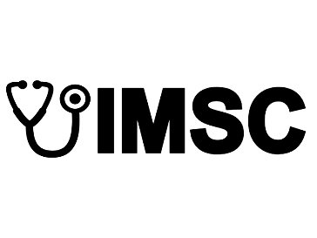

**IMMACULATE MEDICO SURGICAL CLINIC**

**Padre Diaz St. Zone 6, Bulan, Sorsogon**

|  |  |  |  |
| --- | --- | --- | --- |
| **PATIENT NO:** | 4 | **DATE** | November 15, 2023 |
| **NAME** | Adrian Hagosojos | **AGE** | 22 |
| **ADDRESS** | Gubat, Sorsogon | **SEX** | Male |
| **CONTACT NO.** | 09123345567 | **BIRTHDATE** | January 01, 2001 |

**VITAL SIGNS**

|  |  |  |  |  |  |
| --- | --- | --- | --- | --- | --- |
| **BP** | **CR** | **RR** | **T** | **WT** | **HT** |
| 100 | 56 | 43 | 23 | 34 | 35 |

|  |  |
| --- | --- |
| **SYMPTOMS** | **DIAGNOSIS** |
| Headaches | High Blood |

**MEDICATION**

|  |  |  |  |
| --- | --- | --- | --- |
| **MEDICINE NAME** | **DOSAGE** | **UNIT** | **DURATION** |
| Biogesic | 500mg | 2 | 2 times day |
| Biogesic | 500mg | 2 | 2 times day |

**Prepared by:**

_____________________________

**SIGNATURE OVER PRINTED NAME**